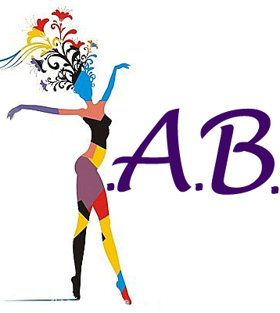
Young, Ambitious and Beautiful Membership Application
Attach a current resume and a letter of interest (including why you would like to be a member of YAB, what Young, Ambitious and Beautiful means to you, what you plan to contribute to YAB and a potential future event) return to 3YAB2012@gmail.com or fax to (866)717-2439.
Personal Information:
Name:
DOB (mm/dd/yy): |  | Email Address:
Mailing Address:
City: | State: |  | Zip: |  | Hometown (if different):
Personal Website:
Blog:
Facebook: www.Facebook.com/ |  |  |  | Twitter: www.Twitter.com/
LinkedIn:

Educational Background:
High school: | City/State:
College: | City/State
Program of Study:
Graduation Date/Expected Graduation Date: | Degree (BA, MS, PhD, etc.)
College: | City/Sate:
Program of Study:
Graduate Date/Expected Graduation Date: | Degree (BA, MS, PhD, etc.)

currently/Future Plans:
Entrepreneur: | Link to business website (if applicable):
Full-time position:
Other:

Nominate a friend:
Name: | Email:
Name: | Email:

